 **NORTH SOUTH UNIVERSITY**

School of Engineering & Physical Sciences

EEE - 111

Analog Electronics I

|  |  |
| --- | --- |
| Submitted To:  Dr. Sharnali Islam  Assistant Professor  Department of Electrical  & Computer Engineering | Submitted By:  Abdullah Al Mamun  1511753642  Mustafizur Rahman  1510078042  Sujit Debnath  1511378642 |

Section-04

Submitted: Wednesday, 15th March, 2017

* **Objective of the project:**

This project is all about USB cell phone charger which can charge any cell phone. This cell phone charger provide 4.7 regulated voltage and sufficient current for the slow charging of any mobile phone.

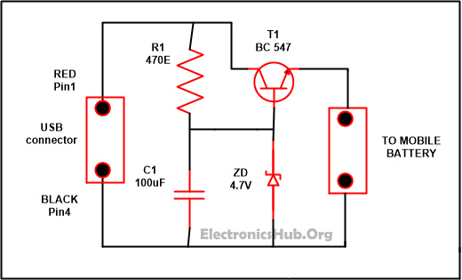

Figure 1: USB mobile charger circuit diagram

* **Require components:**
* Resistor : R1-470E
* Capacitor : C1-100uF/25V
* Transistor : T1-BC547
* Zener diode-4.7V/. 5W
* Diode-1N4007
* A type USB plug
* Female type A USB socket
* Bread board
* Wires
* **Summary of the project plan:**

The circuit of project works on 4.7 regulated voltage and provide sufficient amount of current for the slow charging of the mobile phone. The voltage at the output is harmonized by the transistor named T1. While the output voltage is being controlled by the Zener diode ZD and the polarity of the output which is supply is protected by D1.

'A type' of USB plug will be connected with the front part of the circuit. To ease the polarity identification connects pin1 to the red color wire while the black color of the wire is connected with pin 4. Then we will connect the output of the circuit with the appropriate charger pin to attach it with the cell phone. After doing this, we will put the USB plug in the socket and from the circuit measure the output with the help of digital multimeter. If we got the correct output and if the polarity is connected in the right manner then, we can attach mobile phone with it.